EDRC Use Case 1, Test Case 1, Section 6.1.4 Date
Revision of EDRC doc:

11 | Updated to reflect comments from David Price | K Willshaw  30 March 2015

Test case spec release 1.0

NOTE – The date here is the date on which the Datasheet was last published not a property of the Pump. As we have already established the Datasheet is an instance of ClassOfInformation Object.
The act of Publishing is an Activity so first we need to create the Activity and establish a relationship between the document and Activity.

First we have to declare and classify the Activity of Revising

Role  No | Role Name | Role Type | Example
1 | hasClassified | PossibleIndividual | Uuid of Activity
2 | hasClassifier | ClassOfIndividual | REVISING

Now we can use this in the Template DocumentRevision as shown below.

Role  No | Role Name | Role Type | Example
1 | hasRevisedDocument | dm:ClassOfInformationObject | Uuid of the Data Sheet
2 | hasActivityType | dm:ClassOfActivity | Revising DataSheet P-100-DS
3 | hasActivity | dm:Activity | An automatically generated ID for the Activity
4 | valRevisionDate | dm:RepresentationOfGregorianDateAndUtcTime | The Date/Time of issue

Comment – valRevisionDate does not use the data model, it uses xsd:dateTime datatype - (tpl:valRevisionDate only xsd:dateTime)

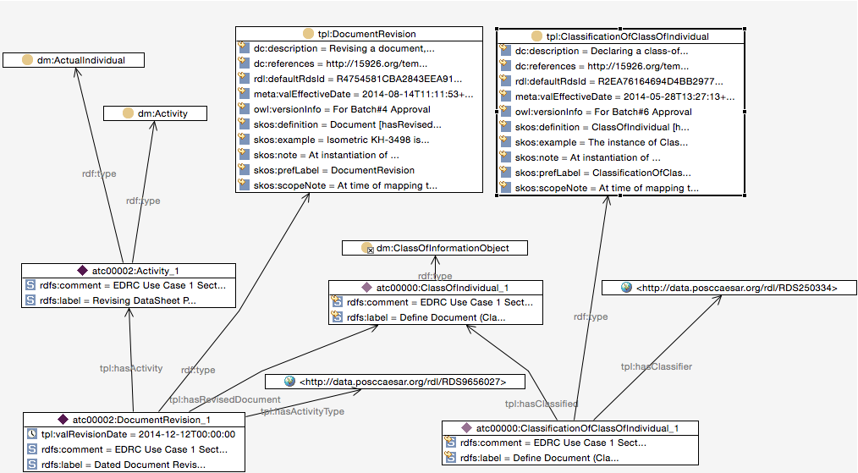

SPARQL to find Revision Date on Data Sheet

SELECT ?RevisionDate
WHERE {
?actualindividual rdf:type dm:ActualIndividual .
?actualindividual rdf:type dm:Activity .
?classofinformationobject rdf:type dm:ClassOfInformationObject .
?documentrevision tpl:hasActivity ?actualindividual .
?documentrevision tpl:hasActivityType <http://data.posccaesar.org/rdl/RDS9656027> .
?documentrevision tpl:hasRevisedDocument ?classofinformationobject .
?documentrevision rdf:type tpl:DocumentRevision .
?classificationofclassofindividual tpl:hasClassified ?classofinformationobject .
?classificationofclassofindividual tpl:hasClassifier <http://data.posccaesar.org/rdl/RDS250334> .
?classificationofclassofindividual rdf:type tpl:ClassificationOfClassOfIndividual .
?documentrevision tpl:valRevisionDate ?RevisionDate .
}

